1. **Online voting system:**

**Functional requirements of online voting system:**

**User registration:**

* **Implement secure authentication for users.**

**Ballot creation and distribution:**

* **Create electronic ballots for various elections.**

**Voting mechanism:**

* **Provide a user-friendly interface for casting votes.**

**Real-time vote counting:**

* **Count votes accurately and in real time.**

**Results display:**

* **Display final voting results transparently.**

**Accessibility:**

* **Ensure the system is accessibility to user with disabilities.**

**Non-functional requirements for online voting system:**

**Security:**

* **Implement robust security measures to prevent tampering.**

**Reliability and availability:**

* **Ensure the system is reliable and available during the voting period.**

**Performance:**

* **Handle high volumes of concurrent users.**

**Scalability:**

* **Design the system to scale with increasing user numbers.**

**Compliance:**

* **Comply with legal and regulatory standards for online voting.**

**User interface:**

* **Design an intuitive and user-friendly interface.**

**Maintainability:**

* **Facilitate easy maintenance and updates to the system.**

**2. Library management system:**

**Functional requirements for library management system:**

**User Management:**

* **Register and authenticate library users.**
* **Manage user profiles, including borrowing history.**

**Catalog Management:**

* **Maintain a database of available books, including details like title, author, genre, and availability.**

**Borrowing and Returning:**

* **Record due dates and manage the return process.**

**Reservation System:**

* **Enable users to reserve books that are currently checked out.**

**Search and Retrieval:**

* **Provide a search function for users to find books easily.**

**Notifications:**

* **Notify users when their reserved books are available.**

**Reports and Analytics:**

* **Generate reports on book usage, popular titles, etc.**

**Non-functional requirements for library management system:**

**Security:**

* **Ensure data privacy and protection against unauthorized access.**

**Reliability and Availability:**

* **Maintain high system reliability to prevent downtime.**

**Performance:**

* **Provide quick response times for search queries and book transactions.**

**Scalability:**

* **Design the system to scale with a growing number of users and books.**

**User Interface:**

* **Design an intuitive and user-friendly interface for both staff and patrons.**

**Data Backup and Recovery:**

* **Regularly back up system data to prevent data loss.**

**Interoperability:**

* **Ensure compatibility with other library systems or databases.**

**Compliance:**

* **Comply with relevant data protection and privacy regulations.**

**3.Online shopping system:**

**Functional requirements for online shopping system:**

**User Registration and Authentication:**

* **Allow users to register securely.**
* **Authenticate users to ensure secure access.**

**Product Catalog:**

* **Display a comprehensive catalog of products.**

**Shopping Cart:**

* **Enable users to add and remove items from their shopping cart.**

**Checkout Process:**

* **Provide a secure and user-friendly checkout process.**

**Order Management:**

* **Generate order confirmations for users.**

**User Reviews and Ratings:**

* **Enable users to leave reviews and ratings for products.**

**User Account Management:**

* **Allow users to manage their profiles, addresses, and payment methods.**

**Non-functional requirements for online shopping system:**

**Security:**

* **Implement secure data transmission and storage.**

**Reliability and Availability:**

* **Maintain high system reliability to prevent service disruptions.**

**Performance:**

* **Provide quick response times for page loading and transaction processing.**

**Scalability:**

* **Design the system to handle increased traffic during peak times.**

**User Interface:**

* **Design an intuitive and visually appealing user interface.**

**Mobile Responsiveness:**

* **Ensure the online shopping platform is responsive and accessible on various devices.**

**Data Backup and Recovery:**

* **Regularly back up transaction and user data.**

**Compliance:**

* **Comply with data protection and privacy regulations.**

**4. Blood donor system:**

**Functional requirements for blood donor system:**

**User Registration and Authentication:**

* **Allow donors to register securely.**
* **Authenticate users to ensure the validity of donor information.**

**Donor Profile Management:**

* **Enable donors to manage their profiles, including contact details and blood type.**

**Blood Bank Inventory:**

* **Maintain an inventory of available blood types.**

**Donation Scheduling:**

* **Provide a system for donors to schedule blood donation appointments.**

**Donor Notifications:**

* **Notify donors about blood donation drives or urgent needs.**

**Blood Donation Process:**

* **Facilitate a smooth and efficient blood donation process.**

**Search and Request System:**

* **Allow hospitals or organizations to search for specific blood types.**

**Non-functional requirement for blood donor system:**

**Security:**

* **Implement secure data storage and transmission.**

**Reliability and Availability:**

* **Maintain high system reliability to ensure availability during emergencies.**

**Performance:**

* **Provide quick response times for donor registrations and inventory updates.**

**Scalability:**

* **Design the system to handle an increasing number of donors and blood bank locations.**

**User Interface:**

* **Design an intuitive and user-friendly interface for both donors and blood bank administrators.**

**Mobile Responsiveness:**

* **Ensure the system is accessible and functional on mobile devices.**

**Data Backup and Recovery:**

* **Regularly back up donor and inventory data.**

**Compliance:**

* **Comply with data protection and privacy regulations.**

**Use case diagram for online ticket reservation system:**

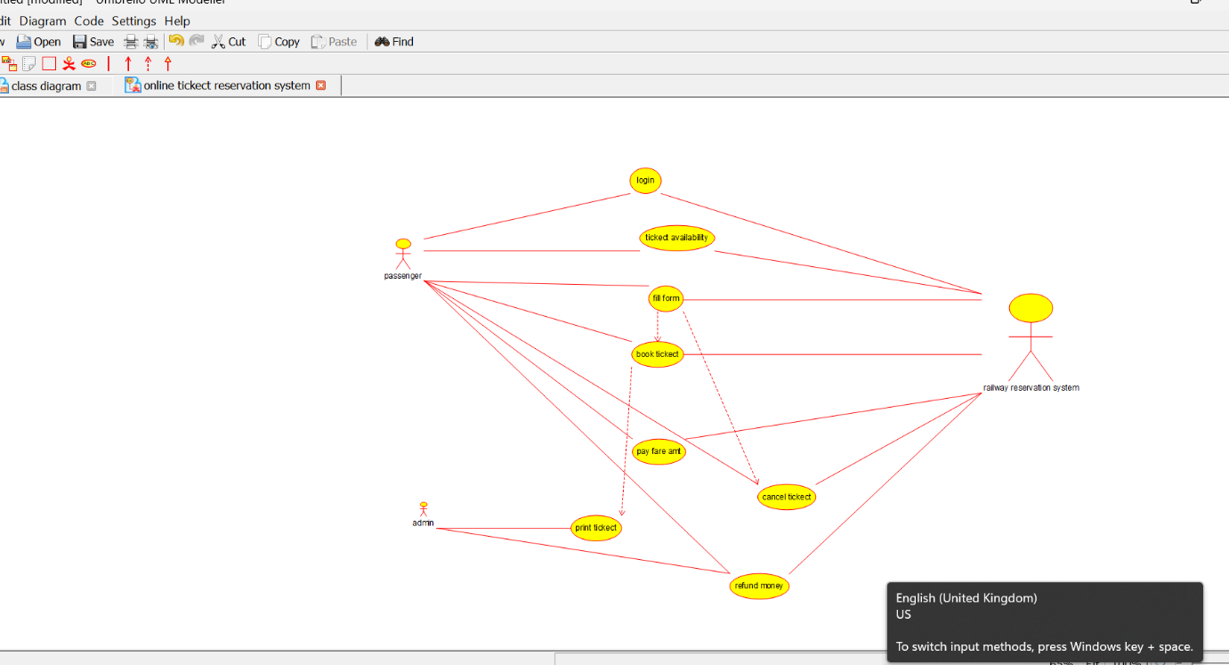

**Class diagram for airline ticket reservation system:**

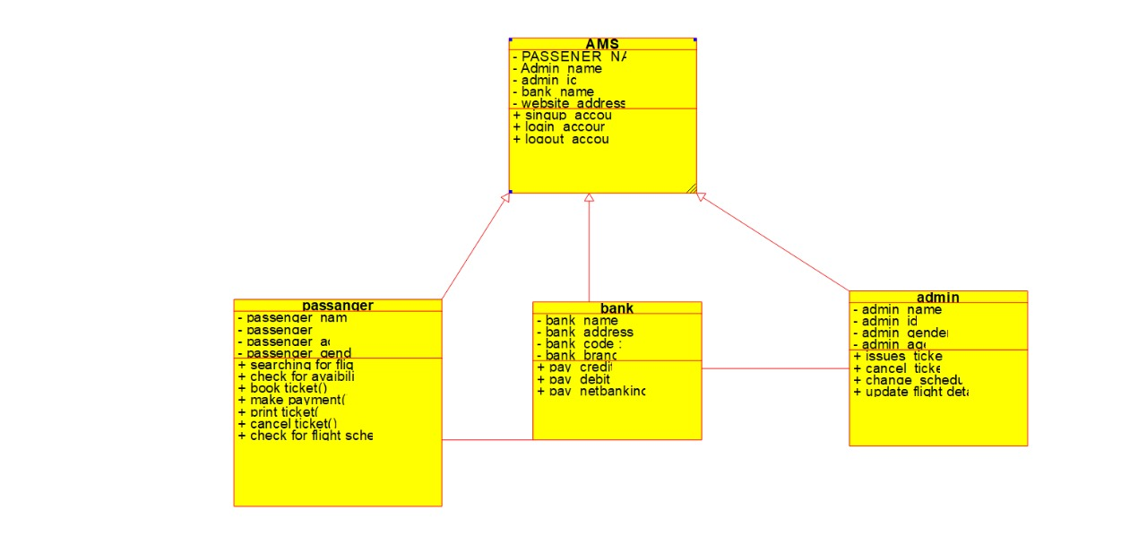

Cyclomatic complexity code:

#include<stdio.h>

int main() {

int E, N, P, CC;

printf("\n Program to find Cyclomatic Complexity:") ;

printf("\n Enter the number of Edges in the flow graph:");

scanf("%d", &E);

printf("\n Enter the number of Nodes in the flow graph:");

scanf("%d", &N);

printf("\n Enter the number of Predicate Nodes in the flow graph:");

scanf("%d", &P);

CC = E - N + (2 * P);

printf("\n The Cyclomatic Complexity of the flow graph is: %d", CC);

return 0;

}